

**DBMS Laboratory**

**(BTCS 505-18)**

**B.Tech CSE 5th**

**2022 Odd**

**CT GROUP OF INSTITUTIONS,**

**Maqsudan**

**Prepared by:**

**Name: Ankush kumar**

**Class: Btech CSE**

**Roll no: 2021963**

**College: CT Group of Institutions, Maqsudan**

|  |  |  |
| --- | --- | --- |
| http://www.ctgroup.in/images/audi/cell/CT%20Logo%20Final.png | **CT Group of Institutions, Maqsudan** | **Department: B.TECH CSE** |
| **Subject Name: DBMS Lab** | **Subject Code: BTCS 505-18** |
| **Course-Semester: B.TECH CSE 5th** | **Faculty Name/Lab Instructor:**  **Mr. Prince Verma** |

**INDEX**

|  |  |  |  |  |
| --- | --- | --- | --- | --- |
| **S. No.** | **Experiment Description** | **Experiment Number**  **CT-Subject-Number**  **(ct-mp-01)** | **Page No** | **Remarks** |
| **1** | **Using DDL COMMANDS** | **CT-DBMS Lab-01** |  |  |
| **2** | **Using DML COMMANDS, COMMIT AND ROLLBACK** | **CT- DBMS Lab-02** |  |  |
| **3** | **Using Operators** | **CT- DBMS Lab-03** |  |  |
| **4** | **Using Single Row Functions** | **CT- DBMS Lab-04** |  |  |
| **5** | **Using Group Function** | **CT- DBMS Lab-05** |  |  |
| **6** | **using SUBqueries/Nested queries** | **CT- DBMS Lab-06** |  |  |
| **7** | **using Joins** | **CT- DBMS Lab-07** |  |  |
| **8** | **USING VIEWS, INDEXES, GRANT AND REVOKE** | **CT- DBMS Lab-08** |  |  |
| **9** | **creating PL/SQL Block** | **CT- DBMS Lab-09** |  |  |
| **10** | **creating and using Stored Procedures** | **CT- DBMS Lab-10** |  |  |
| **11** | **creating and using Cursor in PL/SQL** | **CT- DBMS Lab-11** |  |  |
| **12** | **creating and using Triggers in PL/SQL** | **CT- DBMS Lab-12** |  |  |

|  |  |  |
| --- | --- | --- |
| http://www.ctgroup.in/images/audi/cell/CT%20Logo%20Final.png | **CT Group of Institutions, Maqsudan** | |
| **Experiment Title: Using DDL Commands** | |
| **Laboratory:** DBMS Lab (BTCS 505-18) | **Department: B.TECH CSE** |
| **Experiment No: 1** | **Semester: 5th** | **Page:** 01 of 27 |

* **Various DDL Commands: Create, Drop, Rename, Alter and Truncate**

1. **Create table** DEP table with attributes:

* DEPNO (201, 202,……)
* DNAME
* DHEAD
* LOC

And constraints:

* PRIMARY KEY on DEPNO using table constraints
* DEFAULT on DHEAD
* CHECK on LOC (“Jalandhar”, “ Ludhiana, “Amritsar”, “Bathinda”)
* NOT NULL on DNAME

**Command:**

//create department table

create table dep (

depno number(5),

dname varchar2(10) not null,

dhead varchar2(10) default 'ABC',

Loc varchar2(10) check (Loc in ('JALANDHAR','BHATINDA','AMRITSAR','LUDHIANA')),

constraint dep_depno_pk primary key(depno)

);

**Screenshot:**

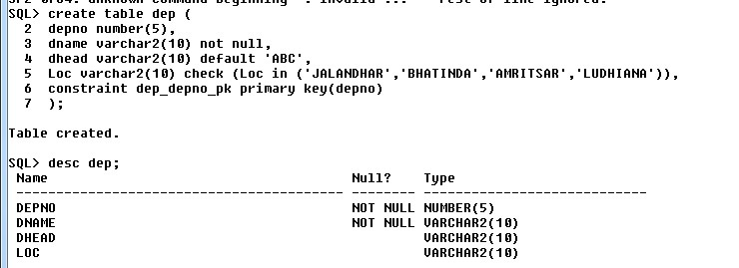

1. **Create table** EMP table with attributes:

* EMPNO (101,102,…..)
* ENAME
* DEPTNO
* JOB
* HIREDATE
* SAL
* COMM
* LOC

And constraints:

* PRIMARY KEY on EMPNO
* FOREIGN KEY on DEPNO with DEPT table using table constraint
* CHECK on JOB (“Manager”, “Clerk”, “Salesman”, “Attendant”)
* UNIQUE on ENAME

**Command:**

//create emplyee table

create table emp(

empno number(10) primary key,

ename varchar2(10) unique,

depno number(5),

job varchar2(10) check (job in('Manager','Clerk','Salesman','Attendent')),

hiredate date,

sal number(10) ,

comm number(10),

Loc varchar2(10),

constraint dep_no foreign key(depno) references dep(depno)

);

**Screenshot:**

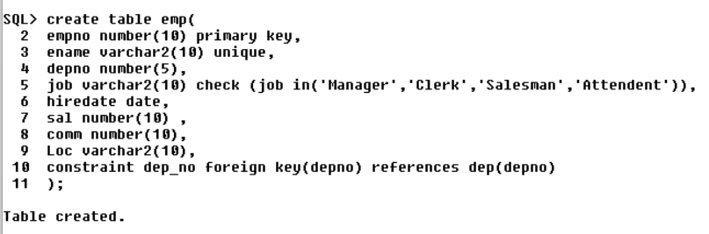

1. **Create table** EMPLOYEE with same column definition of EMP table

**Command:**

create table empl as (select * from emp);

**Screenshot:**

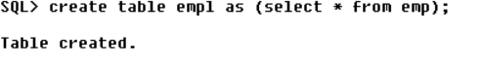

1. **Drop table** EMPLOYEE

**Command:**

drop table empl;

**Screenshot:**

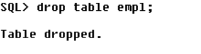

1. **Rename table** DEP to DEPT

**Command:**

rename dep to dept;

**Screenshot:**

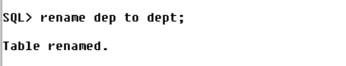

1. **(Alter) Insert column** MGR in EMP table

**Command:**

alter table emp add MGR varchar2(10);

**Screenshot:**

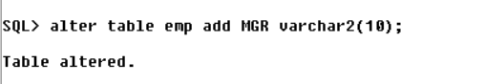

1. **(Alter) Change column** definition (Increase size) of DHEAD of DEP table

**Command:**

alter table dep modify dhead varchar2(20);

**Screenshot:**

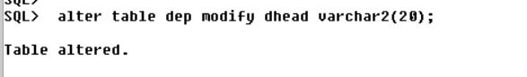

1. **(Alter) Delete column** MGR from EMP table

**Command:**

alter table emp drop column MGR;

**Screenshot:**

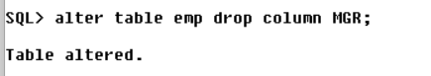

1. **(Alter) Delete constraint** UNIQUE on ENAME of EMP table

**Command:**

alter table emp drop unique(ename);

**Screenshot:**

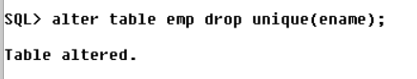

1. **(Alter) Add constraint** CHECK on SAL>10000 to EMP table

**Command:**

alter table emp add constraint sal_greater check(sal>10000);

**Screenshot:**

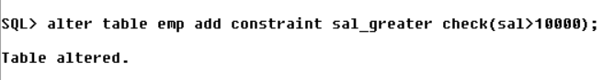

1. **Show column** details of tables:
   1. EMP

**Command:**

desc emp;

**Screenshot:**

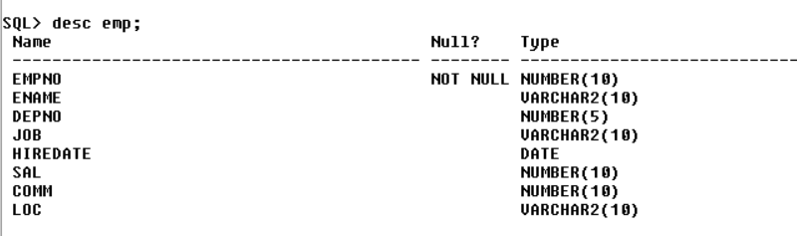

* 1. DEP

**Command:**

desc dep;

**Screenshot:**

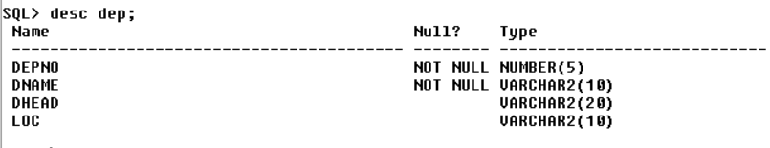

**//For creating employee table**

**Command:**

alter table emp add mgr number(10);

desc emp;

**Screenshot:**

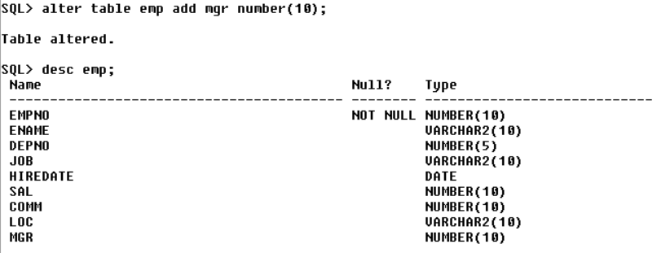

|  |  |  |
| --- | --- | --- |
| http://www.ctgroup.in/images/audi/cell/CT%20Logo%20Final.png | **CT Group of Institutions, Maqsudan** | |
| **Experiment Title: Using DML Commands** | |
| **Laboratory:** DBMS Lab (BTCS 505-18) | **Department: B.TECH CSE** |
| **Experiment No: 2** | **Semester: 5th** | **Page:** 06 of 27 |

* **Various DML Commands: Insert, Delete, Select and Update**

1. **Insert** records in DEPARTMENT table

**Command:**

Insert into dep values(201,’Account’,’Karina’,’LUDHIANA’);

Insert into dep values(202,’Btech’,’Prince’,’JALANDHAR’);

Insert into dep values(203,’Sales’,’Ankit’,’AMRITSAR’);

Insert into dep values(204,’Operation’,null,’BHATINDA’);

**Screenshot:**

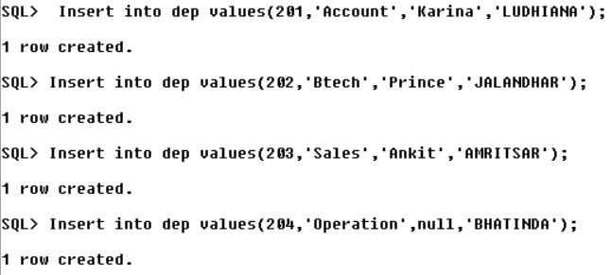

1. **Insert** records in the EMPLOYEE table (Using Input operator)

**Command:**

insert into emp values (&ename,'&ename',&depno,'&job','&hiredate',&sal,&comm,'&loc',&mgr);

**Screenshot:**

1. **(Update)** Change the deptno to 205 of employees (101,102,105)

**Command:**

**Screenshot:**

1. **Delete records** of employees with EMPNO=110

**Command:**

**Screenshot:**

1. **Delete values** of COMM with sal< 11000.

**Command:**

**Screenshot:**

1. **(Select)** Show all records in EMP table

**Command:**

**Screenshot:**

1. Show all records in DEPT table

**Command:**

**Screenshot:**

1. Show all DEPTNO from EMP table without repetition

**Command:**

**Screenshot:**

1. Show all ENAME, JOB, SAL and MGR from EMP table

**Command:**

**Screenshot:**

|  |  |  |
| --- | --- | --- |
| http://www.ctgroup.in/images/audi/cell/CT%20Logo%20Final.png | **CT Group of Institutions, Maqsudan** | |
| **Experiment Title:** **Using** **Operaters** | |
| **Laboratory:** DBMS Lab (BTCS 505-18) | **Department: B.TECH CSE** |
| **Experiment No: 3** | **Semester: 5th** | **Page:** 09 of 27 |

* **Various Operators:**
  1. **Arithmetic Operators: (+ , - , / , * )**
  2. **Logical Operators: (AND / OR / NOT)**
  3. **Comparison Operator:**

**(=, <, >, !=, <>, <=, >=, BETWEEN, IS NULL, LIKE)**

1. Show all ENAME, JOB and ANNUAL SAL from EMP table

**Command:**

**Screenshot:**

1. Show employee’s job record using following format: **(Concatenation)**

“SMITH works as CLERK” And give column an alias.

**Command:**

**Screenshot:**

1. Show all ENAME, DEPTNO and SAL with DEPTNO 101 or 102 Using **OR**

**Command:**

**Screenshot:**

1. Show all ENAME, JOB and SAL with SAL<15000 and SAL>10000 Using **AND**

**Command:**

**Screenshot:**

1. Show all records of employees which are **NOT** Clerk

**Command:**

**Screenshot:**

1. Show entries from EMP table with JOB= ‘SALESMAN’

**Command:**

**Screenshot:**

1. Show all ENAME, DEPTNO and SAL with DEPTNO 101 or 102 Using **IN** clause

**Command:**

**Screenshot:**

1. Show all ENAME, JOB and SAL with SAL<15000 and SAL>10000 Using **BETWEEN** clause

**Command:**

**Screenshot:**

1. Show all ENAME and SAL who works in deptno=201 and sal>1000

**Command:**

**Screenshot:**

1. Show all ENAME and JOB with job containing ‘A’ from the EMP table **(LIKE)**

**Command:**

**Screenshot:**

1. Show all records with NULL values in the COMM column from the EMP table

**Command:**

**Screenshot:**

1. Show all records of the DEPT table ordered by the LOC

**Command:**

**Screenshot:**

1. Show ENAME, DEPTNO and SAL of employee and order result by DEPTNO and then in descending order by SAL

**Command:**

**Screenshot:**

|  |  |  |
| --- | --- | --- |
| http://www.ctgroup.in/images/audi/cell/CT%20Logo%20Final.png | **CT Group of Institutions, Maqsudan** | |
| **Experiment Title: Using Single Row Functions** | |
| **Laboratory:** DBMS Lab (BTCS 505-18) | **Department: B.TECH CSE** |
| **Experiment No: 4** | **Semester: 5th** | **Page:** 14 of 27 |

* **Various Single Row Functions:**

1. **NUMBER Functions: (ROUND, TRUNC)**
2. **CHARACTER Functions: (CONCAT, UPPER, LOWER, INITCAP, INSTR, SUBSTR, REPLACE, LENGTH, LPAD, RPAD, LTRIM, RTRIM)**
3. **DATE Functions: (MONTHS_BETWEEN, ADD_MONTHS, LAST_DAY, NEXT_DAY, ROUND, TRUNC))**
4. Display following details for Employees working for less than 33 years

EMPNO, HIREDATE, Number of Months Employed with No Decimal Places, 6 Months Review Date Rounded-Off by Months, First Friday After HIREDATE and Last Date of the Month he’s Employed

**Command:**

Select empno, hiredate, round(months_between(sysdate,hiredate),0),

round(add_months(hiredate,6),month), next_day(hiredate,’Friday’), last_day(hiredate)

from emp where months_between(sysdate,hiredate),0/12 <33;

**Screenshot:**

1. Find ENAME, JOB joined together the length of ENAME and numeric position of the letter ‘a’ in ENAME for employees whose names end with ‘N’.

**Command:**

**Screenshot:**

1. Find ENAME in capitals, JOB with ‘a’ alphabet replaced with ‘e’, and sal with padding on RHS.

**Command:**

**Screenshot:**

1. Find the alphabets from 2nd to 5th position in ENAME.

**Command:**

**Screenshot:**

|  |  |  |
| --- | --- | --- |
| http://www.ctgroup.in/images/audi/cell/CT%20Logo%20Final.png | **CT Group of Institutions, Maqsudan** | |
| **Experiment Title: Using Group Functions** | |
| **Laboratory:** DBMS Lab (BTCS 505-18) | **Department: B.TECH CSE** |
| **Experiment No: 5** | **Semester: 5th** | **Page:** 16 of 27 |

**Varoius Group Functions: Maximum, Minimum, Count, Sum and Average**

1. Find minimum, maximum and average salary of each department. (Use MIN, MAX, AVG)

**Command:**

**Screenshot:**

1. Find out the total number of employees getting COMM. (Use COUNT)

**Command:**

**Screenshot:**

|  |  |  |
| --- | --- | --- |
| http://www.ctgroup.in/images/audi/cell/CT%20Logo%20Final.png | **CT Group of Institutions, Maqsudan** | |
| **Experiment Title: Using Subqueries or Nested Queries** | |
| **Laboratory:** DBMS Lab (BTCS 505-18) | **Department: B.TECH CSE** |
| **Experiment No: 6** | **Semester: 5th** | **Page:** 17 of 27 |

1. Find ENAME,SAL, DEPTNO of employees having same department as ‘SMITH’ (Use subquery)

**Command:**

**Screenshot:**

1. Find ENAME,SAL, DEPTNO of employees having the same job as of ‘SMITH’ and Saul>5000

**Command:**

**Screenshot:**

1. Find jobs with lowest average salary (use HAVING)

**Command:**

**Screenshot:**

1. Find ENAME,JOB and SAL of employees who are not CLERK and whose SAL is less than that of any CLERK.(use ANY)

**Command:**

**Screenshot:**

1. Find ENAME,JOB and SAL of employees who are not CLERK and whose SAL is less than all employees who are CLERK (use ALL)

**Command:**

**Screenshot:**

1. Find ENAME,JOB and SAL of employees who are not CLERK and whose SAL is same as of CLERK (use IN)

**Command:**

**Screenshot:**

|  |  |  |
| --- | --- | --- |
| http://www.ctgroup.in/images/audi/cell/CT%20Logo%20Final.png | **CT Group of Institutions, Maqsudan** | |
| **Experiment Title: Using Joins** | |
| **Laboratory:** DBMS Lab (BTCS 505-18) | **Department: B.TECH CSE** |
| **Experiment No: 7** | **Semester: 5th** | **Page:** 19 of 27 |

1. Find ENAME, SAL, JOB and DNAME of Employees using equi join

**Command:**

**Screenshot:**

1. Find ENAME, SAL, JOB and DNAME of Employees with right outer joins

**Command:**

**Screenshot:**

1. Find ENAME, SAL, JOB and DNAME of Employees using CROSS JOIN

**Command:**

**Screenshot:**

1. Find ENAME, SAL, JOB and DNAME of Employees using NATURAL JOIN

**Command:**

**Screenshot:**

1. Find ENAME, SAL, JOB and DNAME of Employees with JOIN_USING clause

**Command:**

**Screenshot:**

1. Find ENAME, SAL, JOB and DNAME of Employees with JOIN_ON clause

**Command:**

**Screenshot:**

|  |  |  |
| --- | --- | --- |
| http://www.ctgroup.in/images/audi/cell/CT%20Logo%20Final.png | **CT Group of Institutions, Maqsudan** | **Laboratory Manual** |
| **Experiment Title:**  **Using views, indexes, grant and revoke** | |
| **Laboratory:** DBMS Lab (BTCS 505-18) | **Department: B.TECH CSE** |
| **Experiment No: 8** | **Semester: 5th** | **Page:** 21 of 27 |

1. Create a view with EMPNO, ENAME, JOB and SAL on Employee Table

**Command:**

**Screenshot:**

1. Find ENAME, SAL, JOB of Employees from view

**Command:**

**Screenshot:**

1. Find the effect of change in data of Employee table on view.

**Command:**

**Screenshot:**

1. Create an Index with SAL on Employee Table

**Command:**

**Screenshot:**

1. Use the Grant statement to give the privileges

**Command:**

**Screenshot:**

1. Use the Revoke statement to remove the privileges

**Command:**

**Screenshot:**

|  |  |  |
| --- | --- | --- |
| http://www.ctgroup.in/images/audi/cell/CT%20Logo%20Final.png | **CT Group of Institutions, Maqsudan** | |
| **Experiment Title: Creating PL/SQL Block** | |
| **Laboratory:** DBMS Lab (BTCS 505-18) | **Department: B.TECH CSE** |
| **Experiment No: 9** | **Semester: 5th** | **Page:** 23 of 27 |

1. Write a PL/SQL code to add two numbers and display the result. Read the numbers during run time

**Command:**

Declare

a number (5);

b number (5);

s number (5);

Begin

a:=10;

b:=15;

s:=a+b;

Dbms_output.put_line('Sum of '|| a ||' and ' || b || ' is: ' ||s);

End;

/

**Screenshot:**

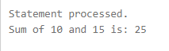

1. Write a PL/SQL code to find the sum of the first 10 natural numbers using for and while loop.

**Command: (i)**

declare

n number(4);

i number(10);

s number(5);

begin

n:=&number;

s:=0;

for i in 1 .. n

loop

s:=s+i;

end loop;

dbms_output.put_line('Sum of first ' || n||' numbers is: ' || s);

end;

/

**Screenshot:**



**Command: (ii)**

declare

n number(4);

i number(10);

s number(5);

begin

n:=&number;

s:=0;

i:=1;

while i<=n

loop

s:=s+i;

i:=i+1;

end loop;

dbms_output.put_line('Sum of first ' || n||' numbers is: ' || s);

end;

/

**Screenshot:**



1. Write a PL/SQL block to count the number of rows affected by an update statement using SQL%ROWCOUNT

**Command:**

Begin

Update emp set sal=sal*0.10 where sal>1000;

Dbms_output.put_line('Number of rows affected ' ||sql%rowcount);

End;

/

**Screenshot:**



1. Write a PL/SQL code to increase the salary of emp by 10% of the given employee.

**Command:**

declare

eno number(4);

sa number(10);

begin

eno:=&emp_no;

select sal into sa from emp where empno=eno;

dbms_output.put_line('Salary of ' || eno|| ' is ' || sa);

sa:=sa*1.10;

update emp set sal=sa where empno=eno;

dbms_output.put_line('New Salary of ' || eno|| ' is ' || sa);

end;

/

**Screenshot**:

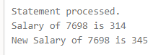

|  |  |  |
| --- | --- | --- |
| http://www.ctgroup.in/images/audi/cell/CT%20Logo%20Final.png | **CT Group of Institutions, Maqsudan** | |
| **Experiment Title: Creating and using Stored Procedures** | |
| **Laboratory:** DBMS Lab (BTCS 505-18) | **Department: B.TECH CSE** |
| **Experiment No: 10** | **Semester: 5th** | **Page:** 25 of 27 |

1. Write a Stored Procedure and call it to increase the salary of any given emp.

**Command:**

Create or replace procedure cp (eno number) as

sa number(10);

begin

select sal into sa from emp where empno=eno;

dbms_output.put_line('Salary of ' || eno|| ' is ' || sa);

sa:=sa*1.10;

update emp set sal=sa where empno=eno;

dbms_output.put_line('New Salary of ' || eno|| ' is ' || sa);

end;

**/**

Exec cp(7698);

**Screenshot:**

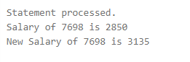

|  |  |  |
| --- | --- | --- |
| http://www.ctgroup.in/images/audi/cell/CT%20Logo%20Final.png | **CT Group of Institutions, Maqsudan** | |
| **Experiment Title: Creating and using Cursor in PL/SQL.** | |
| **Laboratory:** DBMS Lab (BTCS 505-18) | **Department: B.TECH CSE** |
| **Experiment No: 11** | **Semester: 5th** | **Page:** 26 of 27 |

1. Write a program to create a trigger which will keep record of change in salary of employees.

**Command:**

Create or replace procedure cp as

eno number(4);

sa number(10);

cursor c1 is select empno,sal from emp;

begin

open c1;

loop

fetch c1 into eno, ca;

if c1%notfound then exit;

else

if sa<1000 then sa:=sa*1.20;

else sa:=sa*1.10;

end if;

update emp set sal=sa where empno=eno;

dbms_output.put_line(‘Salary of ‘ || eno||’ is updated to ‘ || sa);

end if;

end loop;

close c1;

end;

/

**Screenshot:**

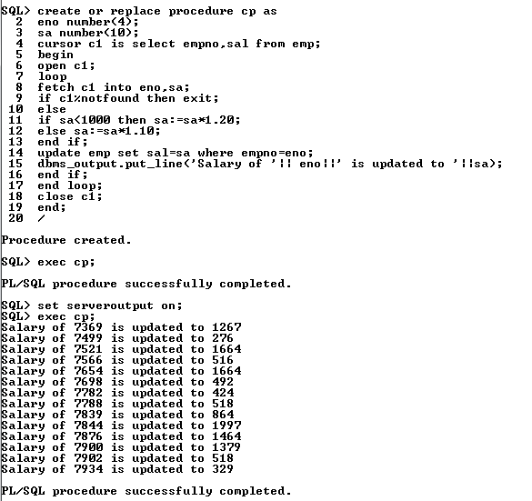

|  |  |  |
| --- | --- | --- |
| http://www.ctgroup.in/images/audi/cell/CT%20Logo%20Final.png | **CT Group of Institutions, Maqsudan** | |
| **Experiment Title: Creating and using Triggers in PL/SQL.** | |
| **Laboratory:** DBMS Lab (BTCS 505-18) | **Department: B.TECH CSE** |
| **Experiment No: 12** | **Semester: 5th** | **Page:** 27 of 27 |

1. Write a program to create a trigger which will keep record of change in salary of employees.

**Command:**

Create or replace trigger empname after insert or update of sal on emp for each row

Begin

Insert into sal_record values(:new.empno,:new.sal, :old.sal, sysdate);

End;

/

**Screenshot:**

